*Florida International University*

*School of Computing and Information Sciences*

Software Engineering Focus

Feature Document

User Story #**134**

**Team Member:**

Nelson Cruz

**Product Owner(s)**:

Mohsen Taheri

**Mentor(s)**:

Mohsen Taheri

**Instructor**: Masoud Sadjadi

**User Story** Implement User Password Reset

* As a User I would like to reset my password

Acceptance Criteria

* A new password is created

**Use Case** #**134**

**Use case name**

Reset password

**Participating actors**

Initiated by Neat User

**Flow of events**

1. While on login screen, user clicks forgot

2. The user is prompted with the forgot password screen

3. User enters his/her username and click request

**Entry condition**

The user is at the login screen

**Exit condition**

The user enters a valid code and is taken to the dashboard

**Quality requirements**

The user is acknowledges of success or failure to register within 5 seconds.

OS X:Users:macbook:Downloads:Password_reset_usecase.png

**Use Case Diagram**

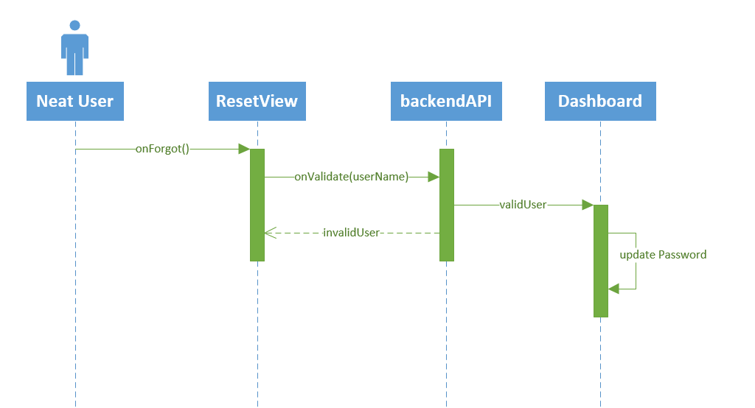

**Sequence Diagram**

OS X:Users:macbook:Pictures:reset_password_class.png

**Class Diagram**

**Unit Test**

**Test Case 1 (Sunny Day)**

**Purpose**

* Ensure the system validates a current user

**Precondition**

* A valid user name is entered by user, the user exists in the system

**Input**

* Valid user name

**Expected Result**

* An e-mail is sent to the user’s primary e-mail address

**Actual Result**

* An e-mail Is received by user with validation code

**Test Case 2 (Rainy Day)**

**Purpose**

* Ensure the system rejects an invalid user

**Precondition**

* An invalid user name is entered by user, the user does not exists in the system

**Input**

* invalid user name

**Expected Result**

* Prompt the user with incorrect user name message

**Actual Result**

* no e-mail Is received by user

**Visual User Guide**

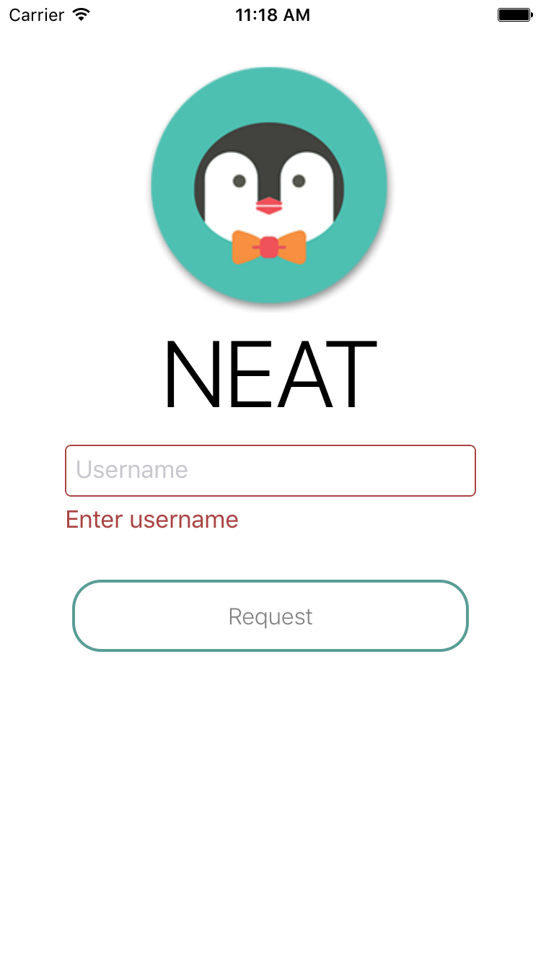 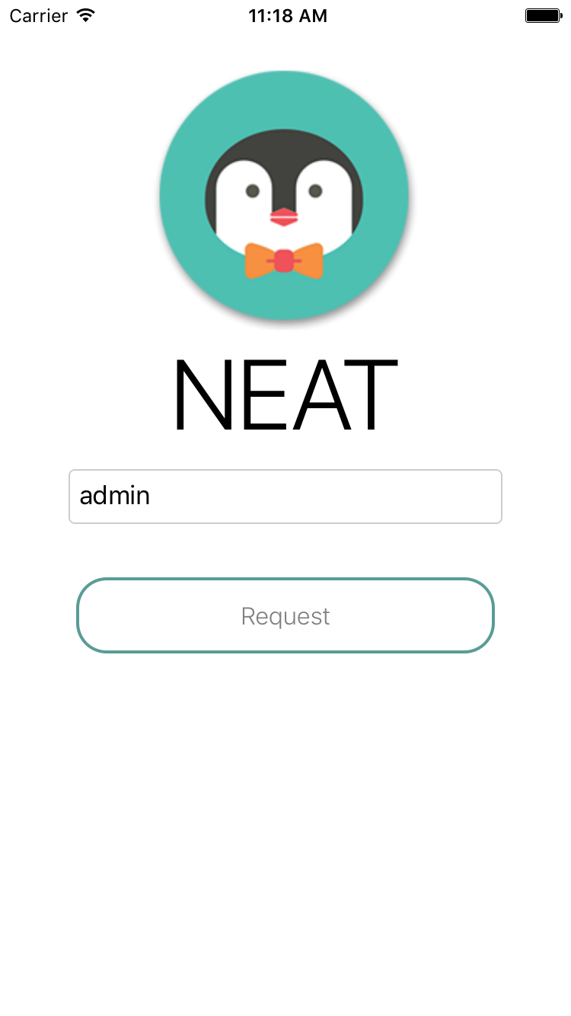

Request password invalid information Request password valid information

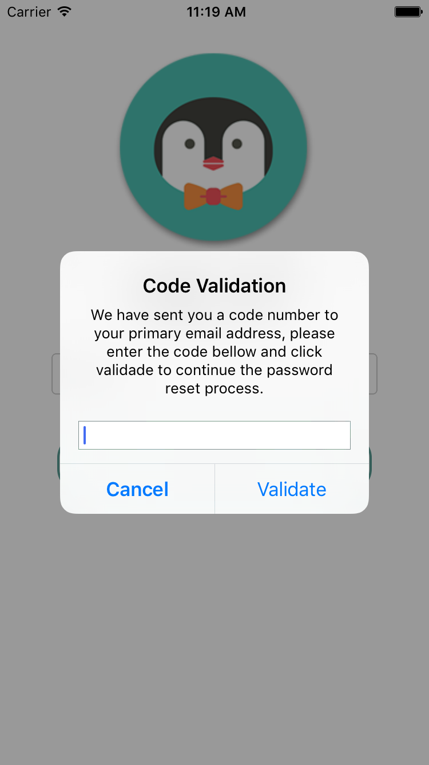 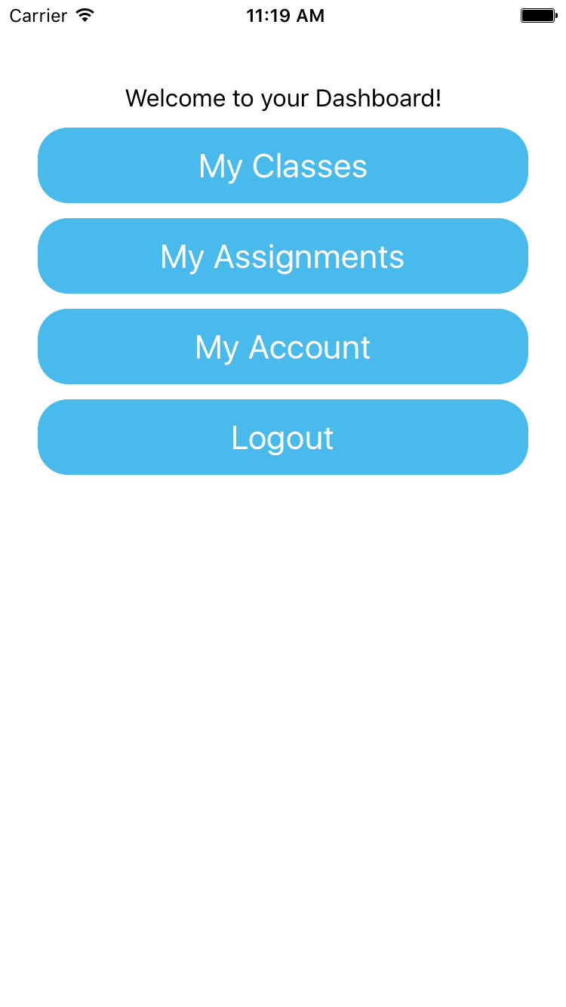

Enter validation code sent to e-mail Go to dashboard after valid code entered